AN ULTRASONIC NAVIGATION SYSTEM FOR BLIND PEOPLE

## ABSTRACT

The aim of this project is to investigate the development of a navigation aid for blind and visually impaired People. It is based on a Arduino with synthetic beep sound is output. This aid is portable and gives information to the user about urban walking routes to point out what decisions to make. On the other hand, and in order to reduce navigation difficulties of the blind, an obstacle detection system using ultrasounds and vibrators is added to this device. The proposed system detects the nearest obstacle via stereoscopic sonar system and sends back vibro-tactile feedback to inform the blind about its localization.

## INTRODUCTION

The motivation of this project was to develop a portable navigation aid for blind pedestrians. The most widely used primary mobility aid today is the long cane. This has several limitations such as a range limited to the length of the cane, typically one pace ahead of the user, difficulties detecting overhanging obstacles, and difficulties storing in public places

In this project, the suggested navigation system involves Arduino with speech output. It is a self contained portable electronic unit. It can supply the blind person with assistance about walking routes by using beep vibration to point out what decisions to make.

In addition, to help blind or visually impaired travellers to navigate safely and quickly among obstacles and other hazards faced by blind pedestrians, an obstacle detection system using ultrasonic sensors and vibrators has been added to this aid. The proposed obstacle detection system consists then in sensing the surrounding environment via sonar sensors and sending vibro-tactile

feedback to the user of the position of the closest

obstacles in range.

## WORKING PRINCIPLE

The aid consists of a microcontroller, an accelerometer, a Footswitch, two ultrasonic sensors, two vibrators and a power switch. Figure 1 shows the block diagram of the system. The obstacle detection part of the system contains two ultrasonic transmitters-receivers and two vibrators. It uses a 40 KHz ultrasonic signal to acquire information and can detect the presence of any obstacle within the specified measurement range of approximately 0.03 to 6 meters. It operates by sending out a pulse of ultrasound. Eventually the pulse is reflected from a solid object in the path of the pulse. The time between the outgoing pulse being transmitted and its echo being received corresponds to the distance between the transmitter and the object or the obstacle. This information is then relayed to the blind in some vibro-tactile way. An increase of distance to an obstacle results in a decrease in vibration, while decrease of distance results in an increase in

vibration.

## Block diagram

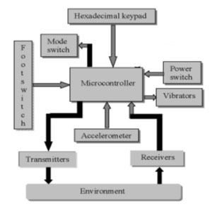

## OBSTACLE DETECTION SYSTEM

As aforementioned and in addition to the other components, this aid is provided with an ultrasonic system attached to the jacket. It is based on two ultrasonic sensors and two vibrators.

### **Ultrasonic sensors**

The sonar system is based on two ultrasonic sensors mounted together. One emits an ultrasonic wave while the other measures the echo. By differentiation of the input and output signals, the PIC 16F876 computes the distance to the nearest obstacle. Then this information is transmitted as a Pulse Wide Modulation (PWM) signal to the receiver. The ultrasonic module used as sensor for this application is the MSU10[17] from ' Lextronic ' and can be seen in figure 3. It has an angle of detection of 720. Vibrators In this system, vibrators from mobile phone technology have been used. Those devices are small and light enough to be fixed on cloth without any obstruction.

### Data treatment

The microcontroller gathers the information from the ultrasonic sensors as PWM signal directly proportional to the distance of the nearest obstacle. Afterwards, it measures the width of the transmitted pulses and converts it into empiric distance.

Following a calibration phase, the real distance between the sensor and the obstacle can determined. The direction is given by comparison of the signal from both sensors. This distance is then converted into a voltage command for appropriate vibrating feedback. The system redirects this information to the actuators via Serial Peripheral Interface. A multi channels D/A Converter recovers 2 integers (address and data) and sends the desired output voltage to the appropriate vibrator.

PROGRAM

#include <NewPing.h>  
  
NewPing blindseye(12,13, 200);  
int buzzer=10;  
int vcc=11;  
   
void setup() {  
  Serial.begin(9600);  
   
  pinMode(buzzer,OUTPUT);  
  pinMode(vcc,OUTPUT);  
  digitalWrite(vcc,HIGH);  
}  
  
void loop()  
{  
  int distance = blindseye.ping_cm();  
  Serial.println(distance);  
  if (distance<200){  
   int dilay = 2*distance;  
  
   digitalWrite(buzzer,HIGH);  
   delay(dilay);  
   digitalWrite(buzzer,LOW);  
   delay(dilay);  
  }  
}

## CONCLUSION

The proposed navigation aid has been developed in order to enhance the independent mobility of blind individuals. The technique well known in aircraft navigation used in this study has reduced errors caused by the accelerometer and double integration. In addition, the use of the footswitch is highly advantageous because without it, drift errors due to the accelerometer and double integration would be considerably greater in magnitude and would reduce the effective range of the electronic travel aid. Although the system detects the nearest obstacle, it cannot solve the blinds' ultimate problem of the environment perception. It has limits due to the characteristics of the ultrasound reflections such that many object can barely be detected, which have very small or soft surfaces .The results obtained are encouraging and further testing on more blind people shall be implemented in the near future.

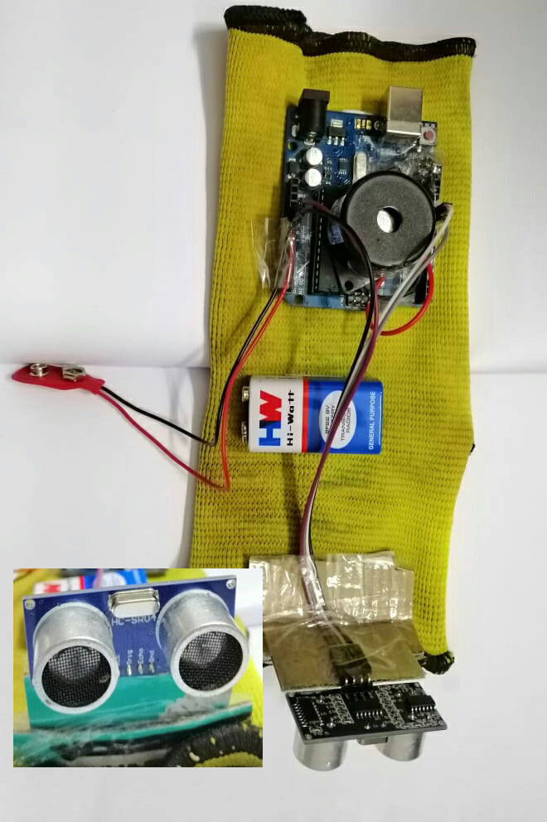

SUBMITTED BY

* NAEEM ABDUL SALAM
* MOHAMMED FASIL KV
* MUHAMMED ANAS K